**Latchup and its prevention in CMOS devices**

**What is Latchup**:

Latchup refers to short circuit formed between power and ground rails in an IC leading to high current and damage to the IC. Speaking about CMOS transistors, latch up is the phenomenon of low impedance path between power rail and ground rail due to interaction between parasitic pnp and npn transistors. The structure formed by these resembles a Silicon Controlled rectifier (SCR, usually known as a thyristor, a PNPN device used in power electronics). These form a +ve feedback loop, short circuit the power rail and ground rail, which eventually causes excessive current, and can even permanently damage the device.

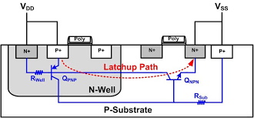 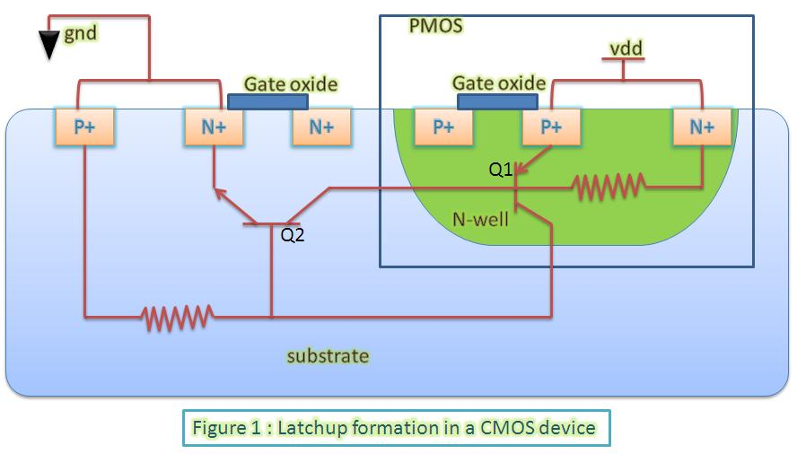

**Latchup formation**: Shown alongside is a CMOS transistor consisting of an NMOS and a PMOS device. Q1 and Q2 are parasitic transistor elements residing inside it. Q1 is double emitter pnp transistor whose base is formed by n well substrate of PMOS, two emitters are formed by source and drain terminal of PMOS and collector is formed by substrate(p type) of NMOS. The reverse is true for Q2. The two parasitic transistors form a positive feedback loop and is equivalent to an SCR (as stated earlier).

**Analysis of latchup formation**: Unless SCR is triggered by an external disturbance, the collector current of both transistors consists of reverse leakage current. But if collector current of one of BJT is temporarily increased by disturbance, resulting positive feedback loop causes current perturbation to be multiplied by β1β2 as explained below. The disturbance may be a spike of input voltage on an input or output pin, leading to junction breakdown, or ionizing radiations.

Because collector current of one transistor Q1 is fed as input base current to another transistor Q2, collector current  of Q2, Ic2 =  β2 * Ib2 and this collector current Ic2 is fed as input base current Ib1  to another transistor  Q1. In this way both transistors feedback each other and the collector current of each goes on multiplying.

**Net gain of SCR device = β1 *β2**

**Total current in one loop = current perturbation * Gain**

If     **β1 *β2 >=1**, both transistors will conduct a high saturation current even after the triggering perturbation is no longer available. This current will eventually becomes so large that it may damage the device.

* **Latch-up prevention techniques**: Simply put, latchup prevention/protection includes putting a high resistance in the path so as to limit the current through supply and make β1 *β2 < 1. This can be done with the help of following techniques:
  + Surrounding PMOS and NMOS transistors with an insulating oxide layer (trench). This breaks parasitic SCR structure.
  + Latchup Protection Technology circuitry which shuts off the device when latchup is detected.